**ENEL102, fall term 2017**

**Assignment 5**

**Function Optimization and Integration**

**(section 9.2 and 9.3 )**

**Due date Nov 13**

**Donald Robert Dunn**

**10152653**

This assignment is based on the material in section 9.2 and 9.3. Suggest you read through these sections first before attempting the assignment questions. As usual, fill in the following template with your Matlab input and output and submit your Word document on D2L.

………………………………………………………………………………………………………………………………..

**Q1** Given a polynomial  we can determine the local maximums by taking the derivative and then finding the roots. Hence in this case we have  such that the root is at 0 indicating a maximum or minimum at that point. We can determine if it is a minimum or a maximum by determining the curvature. In this case the curvature at x=0 is negative so this implies that f(0) is a maximum point.

Consider the polynomial function . Find the real valued extremum of this function and determine if is a maximum or minimum at that point.

**(Matlab input)**

syms x;

f = 5*x^4+4*x^3+3*x^2+2*x+1;

fprime = diff(f,x);

root = solve(fprime,x);

vparoot = vpa(root, 5);

fdoubleprime=diff(fprime,x);

rr = vparoot(1,1) % discovered this was the real roots by viewing all the roots

minimum = subs(fdoubleprime, x, rr) %using the other roots, I discovered this is a minimum

**(Matlab Response)**

rr =

-0.43708017752561545421485789120197

minimum =

6.9724206345346403468795649276907

……………………………………………………………………………………………………………………………………………..

**Q2** Determine the minimum point of  using fminbnd() which is described in section 9.2. Use an interval of -10<x<10.

**(Matlab input)**

f = @(x) 5*x^4+4*x^3+3*x^2+2*x+1;

minimum = fminbnd(f,-10,10)

**(Matlab Response)**

minimum =

-0.4371

………………………………………………………………………………………………………………

**Q3** Numerically integrate the function  from the lower limit of x=0 to the upper limit of x=1 based on using quad().

**(Matlab input)**

f = @(x) sin(x)./(x.^2+1);

fintegrated = quad(f,0,1)

**(Matlab Response)**

fintegrated =

0.3218

………………………………………………………………………………………………………………………………..

**Q4** Numerically integrate the function  from the lower limit of x=-10 to the upper limit of x=10 based on using quad(). Note that if you integrate this directly then you get a NaN (not a number) for the answer. (Hint – you can split your integration into three regions and do a limit operation.)

**(Matlab input)**

**(Matlab Response)**

**Q5** Consider the curve parameterized by the equations

x(t) = sin(2t), y(t) = cos(t), z(t) = t,

and assume a range in the parameter t of . Create a three-dimensional plot of this curve using plot3() with labelled axis.

**(Matlab input)**

t = linspace(0,10);

x = sin(2*t);

y = cos(t);

z = t;

plot3(x,y,z)

title('A5Q5 3D Plot')

zlabel('Z')

xlabel('X')

ylabel('Y')

**(Matlab Response)**

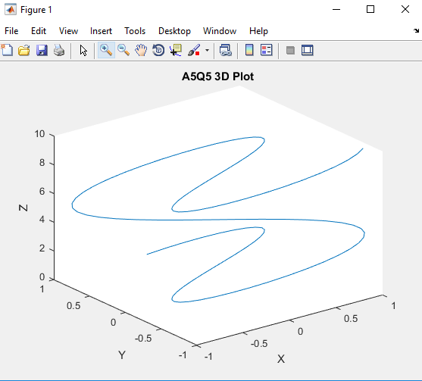

……………………………………………………………………………………………………………………………

**Q6** In this question compute the arc length of the curve in **Q5**.

hint: Recall from calculus that the arc length is given as



**(Matlab input)**

**(Matlab Response)**

……………………………………………………………………………………………………………………………

**Q7** A two dimensional function is given as:





where the units are in meters. Generate a mesh plot of this surface and label the axis.

**(Matlab input)**

**(Matlab Response)**

**Q8** Use a Matlab built-in integration function to determine the volume of the space that is bounded by the surface of , plotted in the previous question, and the plane of z=0 for the extent of



**(Matlab input)**

**(Matlab Response)**

**Q9** Consider a three dimensional scalar function in a Cartesian space given by the value of



Integrate the three dimensional scalar function within a unit sphere that is centered at the origin.

**(Matlab input)**

**(Matlab Response)**